Quantile-Quantile Plots
In my last post, I described data transformations. Specifically, I illustrated the log transform and showed how it led to a very neat model linking brain weight to body weight.
In this article, I take the topic of transformations further and illustrate the square root transform. I also introduce QQ plots and show they can be used.
#R #Rstats #transform #sqrt #datascience #statistics #graphs #plotting #data
The data I use to illustrate this exercise is called Cars93 and it comes with a standard R install within the MASS package. It has data on 93 Cars on Sale in the USA in the year 1993.
The following lines load up the dataset.
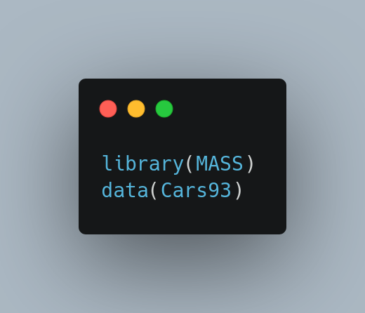

I will be using the variable Price from this dataset, which is nothing but the car price. Lets have a look at this variable.
💡Pro Tip: Notice, that I used the freq = FALSE option, this allows us to treat the histogram as depicting the probability density. This is useful when we want to overlay a theoretical density on the graph.
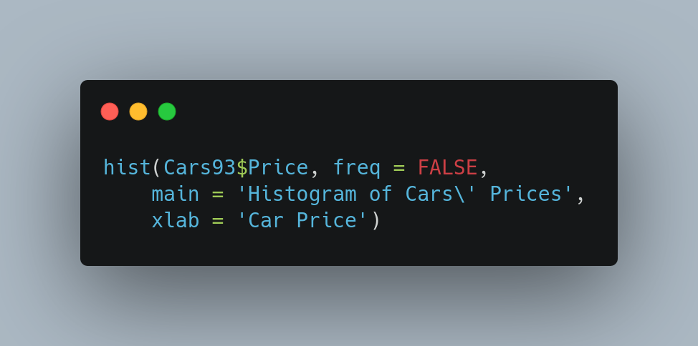
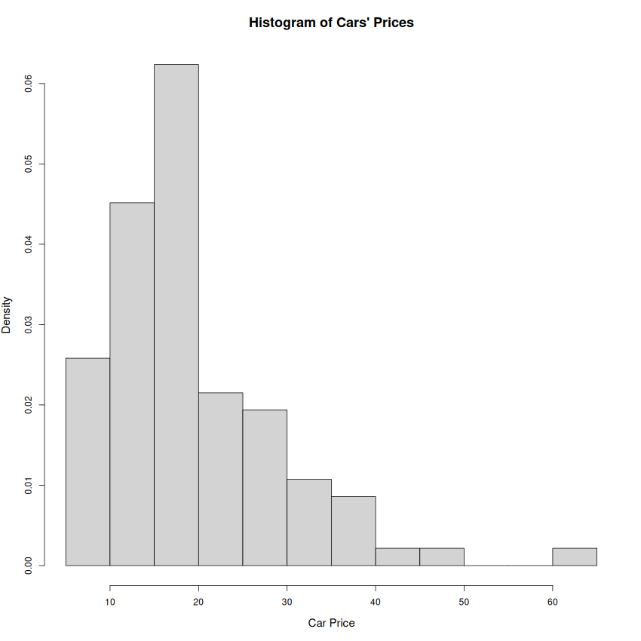

It can be clearly seen that the data is skewed to the right. We know that the gamma distribution is a skewed distribution and we should try modeling the data using this distribution. But the skew is probably too much – so I’ll try to transform the data using the square root transform. Here are the graphs from the two procedures.
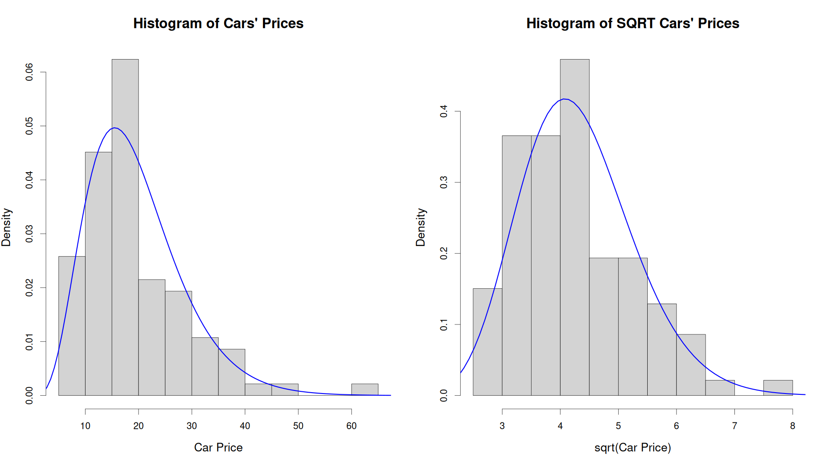
Looking at the two plots, it is very hard to say which is a better fit. The square root has definitely led to a more “peaked” distribution – look at the Y-axis scale – there is an order of magnitude difference there. But beyond the basics one is hard put to choose one of the two models.
This is where the Quantile-Quantile (QQ) plot steps in. A quantile can be thought of as the percentage point (percentile) of a sample. QQ plots visualize the same data as the density-overlaid histograms above, but in a different, and often more useful way.
Here are the QQ-plots for our two models:
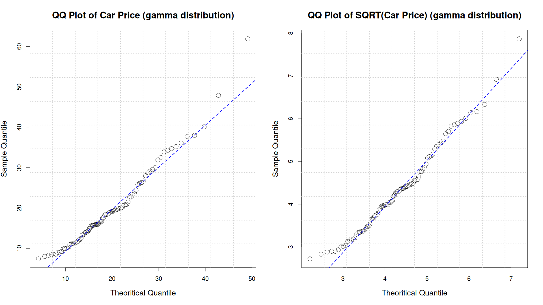
If the models were perfect, then all the points would lie along the line. That however, is not the case here. The left tail seems about fine – there the points follow the line. In the center too, there is not much of a problem.
The biggest difference lies in the right tail. While the left graph (raw Price) shows two outlying points, in the right graph (sqrt Price) the outlying-ness of those two points is much lesser. Overall, it does appear that the square root transform has provided a better fit in the right tail, while losing little, if anything, in the left tail and center.
That’s all folks!

